**COMMUNICATION DIAGRAMS -**

1. Add Preference -

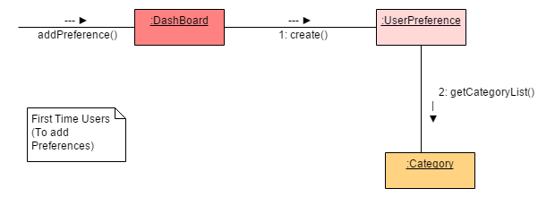

2. View the Registered Events -

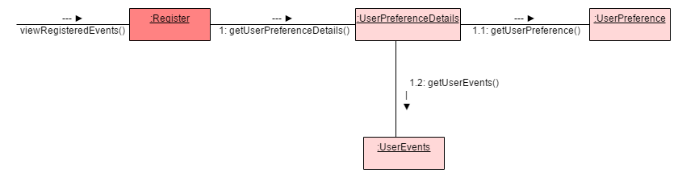

3. Subscribe to a Category -

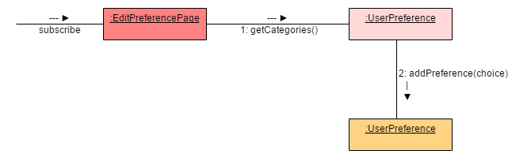

4. Unsubscribe from a Category - 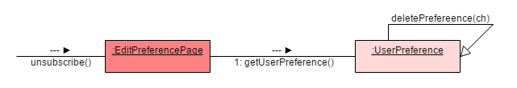

5. Register for Events -

